**Simple Pendulum and Harmonic Motion**

**Pre-lab questions**

1. What is the goal of this experiment? What physics and general science concepts does this activity demonstrate?
2. How can use the period of a pendulum’s motion to measure the acceleration due to gravity *g*?
3. On what does the period of oscillation, *T*, of a simple pendulum with depend?
4. What do we assume by using the small angle approximation?

The goal of the experiment is to study the motion of a simple pendulum and to determine the acceleration due to gravity by measuring the period of a pendulum as a function of the length.

**Equipment:**

* Vertical rod attached to table
* Clamp
* Horizontal rod
* String
* Pendulum bob (hanging masses work well)
* Meterstick
* Stopwatch
* Protractor
* Mass balance

**Introduction:**

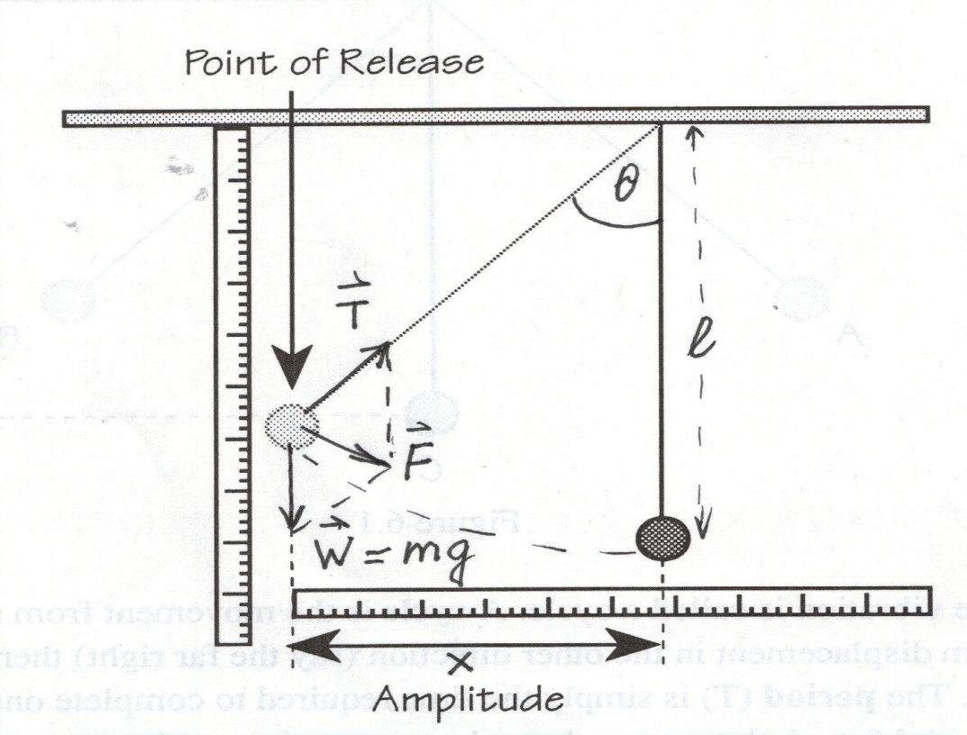A simple pendulum consists of a small massive bob that is supported by a long string and is allowed to swing back and forth in the earth’s gravitational field.

Figure 1: A simple pendulum with free body diagram.

Figure 1 shows a simple pendulum consisting of a ball of mass ***m***, suspended from by a string of length ***l***.

The forces acting on the ball are the force of gravity ***W = mg***, and the tension ***T*** in the string. The resulting net force ***F*** of these two forces is the restoring force acting on the bob’s mass***m*** that tends to return it to its equilibrium position.

From the free body diagram in Figure 1, the restoring force is the component of the weight tangent to the arc: $\begin{aligned}F = - mg \sin{θ} \#\left(1\right)\end{aligned}$

For small angles (less than 15o) there is a very good approximation:

$$\begin{aligned}\sin{θ}=\frac{x}{l}\#\left(2\right)\end{aligned}$$

where ***x*** is displacement of the bob from the equilibrium position, or amplitude.

Thus, for restoring force (similar to the restoring force for a spring) we have: $\begin{aligned}F = - \frac{mg}{l} x = - k x\#\left(3\right)\end{aligned}$

where ***k*** is the effective force constant: $\begin{aligned}k=\frac{mg}{l}\#\left(4\right)\end{aligned}$

A pendulum exhibits simple harmonic motion. The period ***T***of a simple pendulum can be found using equation for spring period of oscillation: $\begin{aligned}T = 2π\sqrt{\frac{m}{k}}\#\left(5\right)\end{aligned}$

Substituting ***k*** from equation (4):

$\begin{aligned}T= 2π\sqrt{\frac{m}{\frac{mg}{l}}} = 2π\sqrt{\frac{l}{g}}\#\left(6\right)\end{aligned}$

where ***l*** - is the length of pendulum,

$g$-is the acceleration due to gravity.

Thus, the period of oscillation ***T*** does not depend on the amplitude or mass of the pendulum. This discovery led to the pendulum clock, the first really precise timepiece which became the standard for centuries.

The relationship given by equation (6) can be used to determine ***g,*** acceleration due to gravity, if the period ***T*** and the pendulum length ***l*** are measured. $\begin{aligned}T^{2}= \frac{{4π}^{2}}{g}l\#\left(7\right)\end{aligned}$

In this experiment you will make measurements of the period for various pendulum lengths. Plotting $T^{2} vs l$ you can determine the value of the slope of the graph that is the coefficient $\frac{{4π}^{2}}{g}$ from which you can infer the value of $g$.

This is the most accurate way to measure $g.$

**Experiment**

* Make a pendulum of about 80-cm, and measure the length ***l***. [The length should be measured from the pivot point to the center of mass of the pendulum bob.]
* Swing the pendulum with small initial amplitude (less than 15°).
  + Measure the time for 30 cycles of the pendulum. The pendulum returning to the same position while moving in the same direction determines one cycle.
  + Record the data in Table 1 provided below.
  + Repeat this measurement for a total of three trials.
  + Take a simple average of the three trials.
  + Divide the average time by 30 to get the period that is the time for one cycle. Record this in Table 1 as well.
* Shorten the pendulum by about 20 cm, and measure the length and the period by the same method.
* Repeat this procedure until you have average period measurements for four different lengths.
* For one of the pendulum lengths in your data, swing the pendulum with initial amplitude of about 30o, and measure the period. This is no longer a small angle. Record your data in the Table 2 to compare with the period of small oscillations of the same pendulum.
* For one of the pendulum lengths in your data, make a pendulum with another bob of different mass (you can add some mass to the bob) and measure the period of this pendulum.
* Compare the periods of the pendulums with different masses in Table 3 provided below.

**Data:**

Table 1: Data for different pendulum lengths

|  |  |  |  |  |
| --- | --- | --- | --- | --- |
| Length *l* [m] | Time for 30 cycles [s] | Average time for 30 cycles [s] | Period *T* [s] | Period squared *T2* [s2] |
|  |  |  |  |  |
|  |
|  |
|  |  |  |  |  |
|  |
|  |
|  |  |  |  |  |
|  |
|  |
|  |  |  |  |  |
|  |
|  |

Table 2: Data for different initial amplitude of pendulum.

|  |  |  |  |  |
| --- | --- | --- | --- | --- |
|  | Length *l* [m] | Time for 30 cycles [s] | Average time for 30 cycles [s] | Period *T* [s] |
| Small amplitude |  |  |  |  |
|  |
|  |
| Large amplitude |  |  |  |  |
|  |
|  |

Table 3: Data for different mass of pendulum bob.

|  |  |  |  |  |
| --- | --- | --- | --- | --- |
| Mass *m* [kg] | Length *l* [m] | Time for 30 cycles [s] | Average time for 30 cycles [s] | Period *T* [s] |
|  |  |  |  |  |
|  |
|  |
|  |  |  |  |  |
|  |
|  |

Additional observations:

**Computations and Analysis:**

* Plot T2 (y-axis) vs. *l* (x-axis) from Table 1.
* The graph should have a linear shape with a line of best fit equation of the form $y=mx$. Force the intercept through 0,0 to remove any additional terms from the equation.
* Use this line of best fit to find the slope of the graph (m). Compare the equation of the line to equation (7) in the introduction. Keep in mind that *l* is represented by *x* and *T2* is represented by *y* in this graph.
* Find an experimental value for *g* using the graph. Show your work below:
* Compare your experimental value for *g* with the accepted value. Calculate percent error. Show your work below:
* What effect does the larger amplitude have on the period of the pendulum (Table 2)?
* Did the mass of the pendulum affect its period (Table 3)?

**Conclusions:**

1. Does the period of motion depend on the pendulum length? Explain.
2. Does the value calculated for *g* depend on the pendulum length? Justify your answer.
3. Based on your understanding of the introduction, do you expect the larger amplitude to have an effect on the period of the pendulum? What simplifications were made to $\sin{θ}$ in our equations, and when is that simplification valid?
4. Based on your understanding of the introduction, do you expect the change in mass to affect the pendulum’s period of motion? Explain.
5. Additional conclusions:

**Sources of errors:**

What assumptions were made that caused error? What is the uncertainty in your final calculation due to measurement limitations?